Plum Borough School District

Expires: 3/31/15
Prepared by: Sean Kruglak
3033 Wilson Boulevard, Suite 500, Arlington, VA 22201
phone: 703-859-7368 | e-mail: sean.kruglak@hobsons.com

Hobsons Overview

At Hobsons, our mission is to maximize student success and institutional effectiveness to create the world-changers of tomorrow. We believe in the transformative power of education and the opportunity it provides for successful outcomes in all aspects of life.

Since our founding in 1974 we’ve grown to become one of the leading education technology companies in the world, serving millions of students across more than 7,500 schools, colleges, universities and nonprofits. Our strong relationships in the teaching and learning community provide us with the knowledge we need to offer a broad range of solutions that meet the challenges faced by students at all stages of the “P-20” education pipeline.

We understand that the decisions students make are cumulative, and academic choices made early on have a far-reaching impact on their futures. Students who make the connection between learning and life success become more personally invested in their education and are more apt to take advantage of the resources available to them.

The solutions offered by Hobsons increase student and family engagement as well as provide a robust set of tools to improve academic performance. By capturing more data and reporting and analytics, Hobsons empowers teachers, counselors and administrators with new ways to monitor and evaluate students’ progress.

At the core of the Hobsons K-12 portfolio is Naviance, the world’s most widely adopted college and career readiness platform.

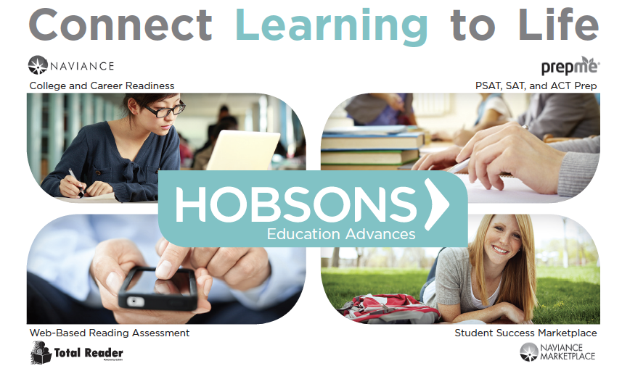
Naviance
Naviance is a college and career readiness platform that helps connect academic achievement to post-secondary goals. Its comprehensive college and career planning solutions optimize student success, enhance school counselor productivity, and track results for school and district administrators.

Naviance enables schools and districts to create personalized success plans for each of their students, and aligns to many state mandates for individual learning plans. The solution offers a core set of functionality that enables students and counselors to connect college and career planning to individual student goals. The platform allows students to collaborate with educators to: set personal goals and tasks; search for colleges; and explore careers based on personal skills and interests.

In addition, the Naviance platform offers schools and districts the flexibility to customize the solution to their needs, and add additional functionality that extend the reach of their college and career readiness efforts. These solutions include:

- Adaptive Test Preparation for PSAT, SAT and ACT
- Electronic Transcript and Document Exchange
- Online Reading Assessment
- Course Planning
- Alumni Tracking

Naviance customers also have access to a wide variety of third-party solutions through the Naviance Marketplace. The Naviance Marketplace offers best-in-class tools that are integrated with Naviance to support college and career readiness efforts. Learn more at http://www.naviance.com/marketplace

The following sections provide more detailed information on the elements of the Naviance platform included in this proposal.

Student and Family Portal
The Naviance Family Connection portal provides students and parents with web-based access to all the tools needed to communicate with school counselors and other staff about their post-secondary goals. Schools can enable optional features within Family Connection to help achieve personal goals through increased academic rigor, including test preparation, reading assessment, course planning, and math and science help.

Goal Setting and Task Management
Naviance offers a robust set of tools to help students tie college and career planning efforts to specific tasks and goals. The solution provides schools the ability to customize the career and college readiness experience by school, grade-level, group and individual student. Naviance ensures that every student has meaningful goals for the future, and an action-oriented plan for achieving his or her goals.

Counselors, teachers and parents are equipped with the tools and data to effectively monitor and coach students toward their goals. Schools and districts can create a library of tasks using rich content including images, media files and document attachments. Tasks can be created for each student or batch-assigned by grade level or other student groupings. Ongoing progress against each task can be viewed by staff and commented on by the students, with records kept in the Naviance system.

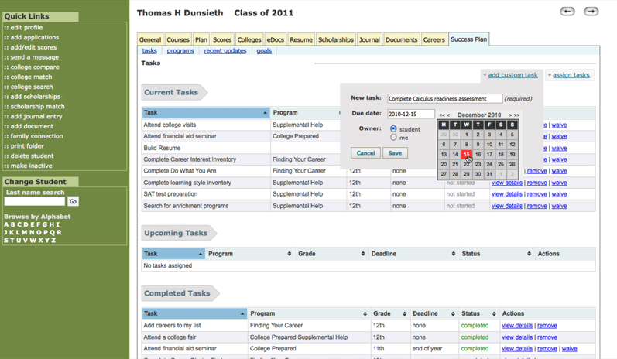

This provides the basis for a comprehensive college and career readiness program that enables school and district administrators to track student progress towards goals and identify areas for improvement, in addition to college and career search tools. All functional areas work together to promote college and career readiness and help facilitate the successful transition of students from secondary to post-secondary success.

Learn more at http://vimeo.com/55952408.

College Search and Planning
Naviance creates and supports a college-going culture by encouraging all students to explore post-secondary education options. Students and parents are given valuable insight into the college admissions process with the best college search tools on the market, including scattergrams, college visit scheduling, scholarship opportunities, application statistics and much more. Students can track their college applications and clearly see what still needs to be done, make sure they are meeting deadlines, and even make requests for transcripts or teacher recommendations.

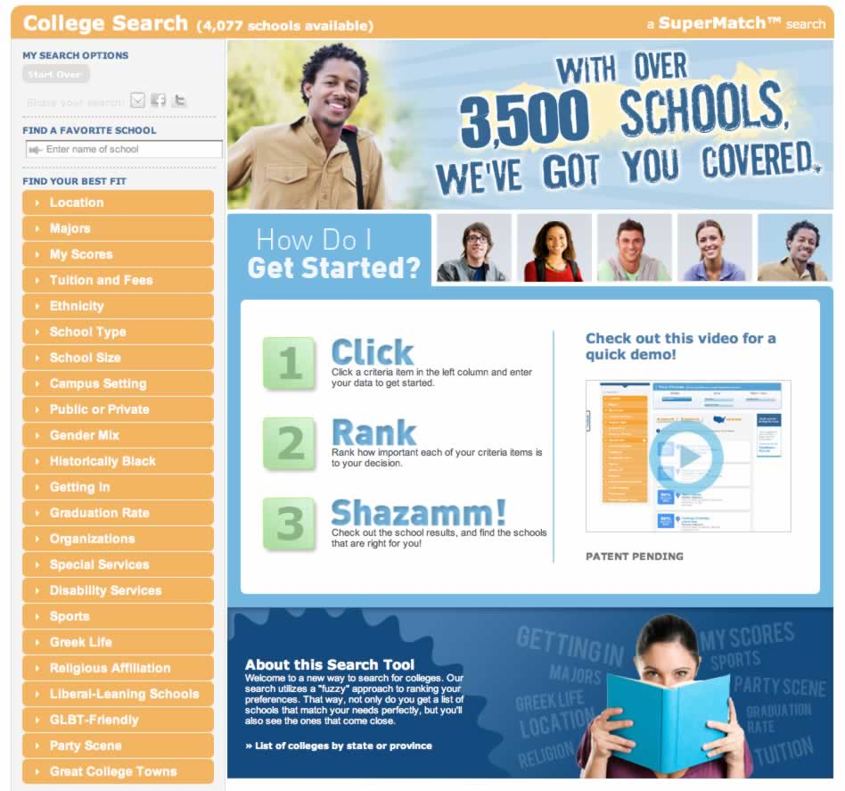
Counselors and teachers are able to manage the college advising process and assist students with planning, preparation, and eventual enrollment in post-secondary institutions. Counselors can track applications, teacher recommendations, record transcript requests, track student milestone completion, survey students on multiple issues, personalize mass communications, and more. With Naviance, students can also research extra-curricular and academic enrichment programs.

Multiple reports provide insight into individual school and overall district progress on college admissions. You can quickly generate reports on student outcomes and disaggregate by gender, ethnicity, or other groupings.

Learn more at: http://vimeo.com/55967630.

Self-Discovery and Career Exploration
Naviance empowers middle and high school students to learn more about themselves by linking personality type and interests with career clusters and individual careers. Students can identify promising careers and understand the academic preparation required to ensure workplace readiness.

Naviance provides self-discovery and career exploration tools throughout the student lifecycle, including Career Key™, a validated and age-appropriate career search and survey tool designed specifically for middle school students, and Do What You Are™ and the Career Interest Profiler, which allow high school students to explore potential careers from both a personality and interest viewpoint. Do What You Are™ and the Career Interest Profiler are validated and age appropriate career surveys for high school students.

Naviance offers career descriptions, academic preparation and requirements, and wage information at the city, state, and national level for more than 1,000 careers with their associated Holland profiles. More than 600 of the careers have videos associated with them, many offered in English and Spanish.
Naviance reporting tools give teachers, counselors and administrators comprehensive information regarding student career interests to guide curriculum planning, career days, and other activities.

Learn more at http://vimeo.com/24627921.

Electronic Document Preparation and Transfer
Though our exclusive relationship with Parchment® (providers of the Docufide® platform), Hobsons allows high school counselors, registrars, and teachers to securely send student application forms, recommendations, transcripts, and school profiles electronically to more than 1,800 participating colleges and universities – including all members of the Common Application.
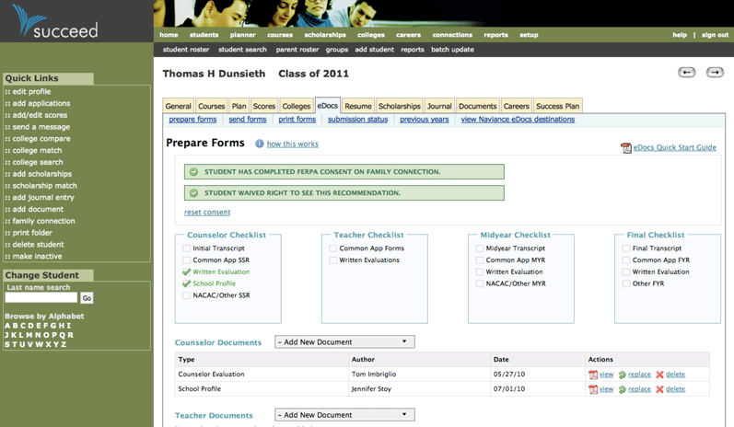
Naviance eDocs saves time and money while reducing the stress associated with meeting deadlines for delivering credentials throughout the college admissions process. Students can view the status of their application materials in Family Connection, keeping them informed without additional e-mails and phone calls to staff.

Learn more at http://vimeo.com/24627997.

Alumni College Tracking
Only Naviance makes it possible to integrate data from the National Student Clearinghouse® about graduates’ college enrollment and completion with the world’s premier student success platform. Schools and districts can determine how their graduates are performing after high school and report on progress. The data also help schools to focus on opportunities to improve the college-going culture for all students.
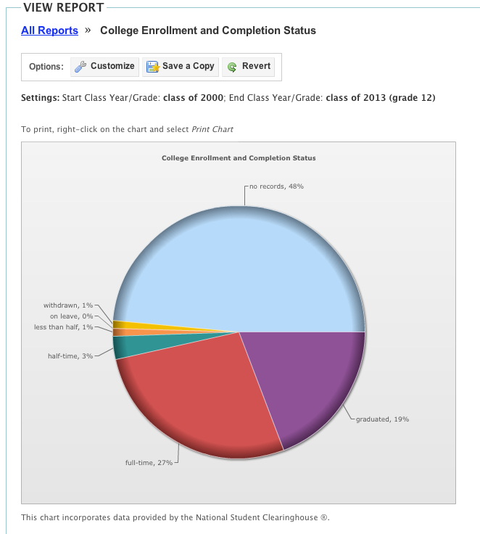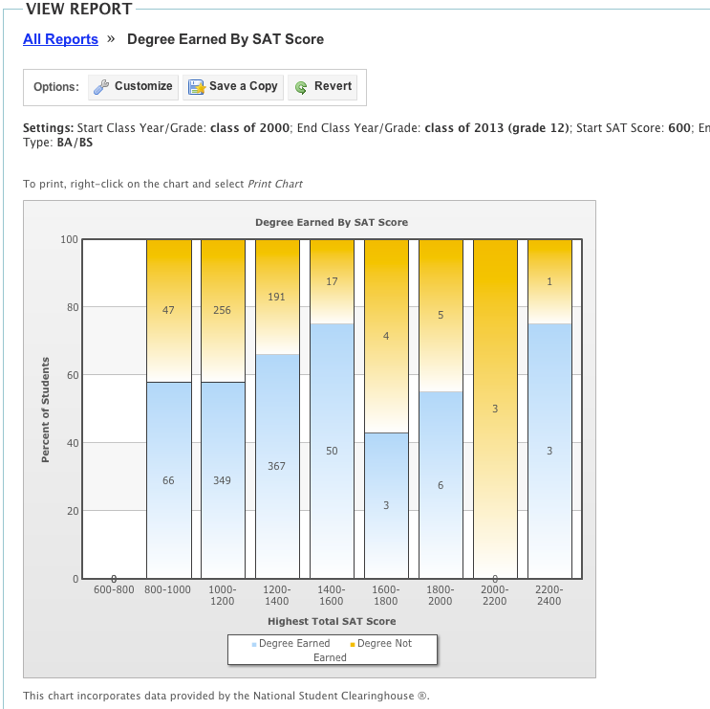

Schools can submit alumni information to the Clearinghouse directly from Naviance, and the Clearinghouse automatically populates post-secondary outcomes. Naviance allows schools and districts to deliver much greater functionality at a much lower cost versus building a separate data warehouse to track alumni outcomes. As a result, schools can save tens of thousands of dollars and hundreds of staff hours while making data more readily available to educators and families through a system they already depend on in their daily work.

Learn more at http://vimeo.com/49241206.

Implementation, Professional Development, and Support

Hobsons K-12 solutions have been successfully deployed at thousands of schools, and we use that experience to ensure that new users can quickly and begin realizing the benefits of our solutions through our required training, consulting and expert customer service.

Professional Development - Training
Part of our methodology for successful deployment of Naviance for a school or district is incorporating professional development for staff into every implementation. The Hobsons Professional Development team crafts learning plans so that right users receive the right training at the right time.

We offer flexible options for training school staff, with onsite sessions and web-based courses, as well as online tutorials and help topics that can be accessed at any time. We also have train-the-trainer programs to assist schools in training their students and parents. All courses can be taken in web-based format or in-person at the school’s location. Our comprehensive curriculum coupled with highly professional course instruction provides Naviance Advantage users with the skills and knowledge needed to effectively utilize the Naviance solution.

Implementation – Guide
For all of our new schools and districts, our Implementation Guide provides best practices and strategies including worksheets, checklists, and templates to ensure a smooth and timely rollout to school staff, students and families. This includes sample timelines, data import checklists, configuration ideas and recommended activities and milestones for staff and students broken down by grade level.

As you launch or expand your Naviance usage, our Implementation Guide provides you with best practices and strategies including worksheets, checklists, and templates to ensure a smooth and timely rollout to your school staff, students, and families.

In this guide, you will receive:
- Consulting Services Methodology: A proven five-phase approach and framework for implementation used by Naviance consultants.
- Processing Worksheets: Templates to establish goals, requirements, dependencies and risks for the implementation plan.
- Sample 90-day Implementation Timeline: Overview of tasks, deliverables, responsible parties, and estimated timeframe by phase that can be tailored to school or district objectives.
- School Activity Calendar and Checklist: Recommended activities and milestones for staff and students by grade level.
- Data Import Checklists: Overview of the type of data and the list of required and recommended fields for importing data into Naviance.
- Configuration Recommendations: Suggestions for creating roles, rights, and permissions and activating the appropriate school- and district-wide settings.
- Family Connection Rollout Strategy: Guidelines for establishing a communication and engagement plan for students including surveys, curriculum, and a checklist of features available by functional area.
- Key Performance Indicators: Matrix of reports available to measure progress against five key indicators – student growth and proficiency; college planning; career planning; student and family engagement; and alumni performance.

Support
Hobsons employs more than 150 staff members dedicated to developing and supporting our Naviance platform. The staff consists of a team of success managers, training specialists, consultants, technical support specialists and product engineers dedicated to supporting our clients in utilizing Naviance to achieve their student success objectives.

Once a school or district becomes a Hobsons client, they are assigned a Success Manager who serves as a single point of contact for all dialogue between the school or district and Hobsons. The Success Manager ensures our client stays well informed of Naviance events and communications, including updates, changes and new features of the Naviance solution. They represent the client’s “voice” to Naviance on enhancement requests as well as any other feedback they have on the Naviance solution.

In addition to having the support of a Naviance Consultant and Trainer throughout the implementation life cycle, a school or district will also have access to Naviance Support Services to answer their questions related to system usage and functionality. Technical support is provided for all school users at no charge. Any school staff that has an active Naviance account can contact Naviance support via phone, email or through online help in Naviance. Naviance Support Services hours of operation are 8:00am – 7:00pm EST weekdays only. If the staff member does not submit their inquiry via phone (not a live call), then RISD can expect a 2-hour response time to inquiries submitted during business hours. A Naviance Support Specialist will respond to inquiries submitted on weekends or after hours on the next business day.

To ensure that quality support is provided at all times, Hobsons measures the success of average response time and client satisfaction ratings. We have a long history of customer satisfaction and as a result over 90% of all Naviance users renew their use of the platform every year.

Plum Borough School District
Solution | Year1 | Year 2 | Year 3
Naviance High School $2.10 per student x 1200 students | $2,520 | $2,520 | $2,520
eDOCs | $500 | $500 | $500
Alumni Tracker ( will be $425 once your seniors graduate) | $425 | $425 | $425
Training ($750 each- Web Based 4 hrs) x3 | $2,250
Implementation Enablement Package  ($1,500) Includes Implementation Guide, Teacher Connection Engagement Package & Family Connection Engagement Package) | $1,500
Discount 25% on products | $1,236.25 | $861.25 | $861.25
Investment | $5,958.75 | $2,794 | $2,794
Total Cost $11,546.75 over 3 years

Total Due $11,546.75 split evenly to 3 payments of $3,848.92
7/1/15-$3,848.92
7/1/16- $3,848.92
7/1/17- $3,848.92

